Book Library Group Test Case Planning

As we have just successfully attached our database to our frontend less than a week before the sprint 2 end, we have not begun test cases at this time, as we had nothing to properly test. However, we do have a plan for our testing and have conducted some informal testing, which is outlined below:

* Registration testing:
  + User properly added to database
    - Once all the information is properly added to the registration, clicking the register now button will add the user to the database as shown in the database below.
    - All information in the database is fake testing data, no security issues violated by showing this data.
    - Email verification does still need to be set up, this will include adding an alert for users for a successful registration.
    - We are also working on figuring out how to clear the password box after the user hits register.

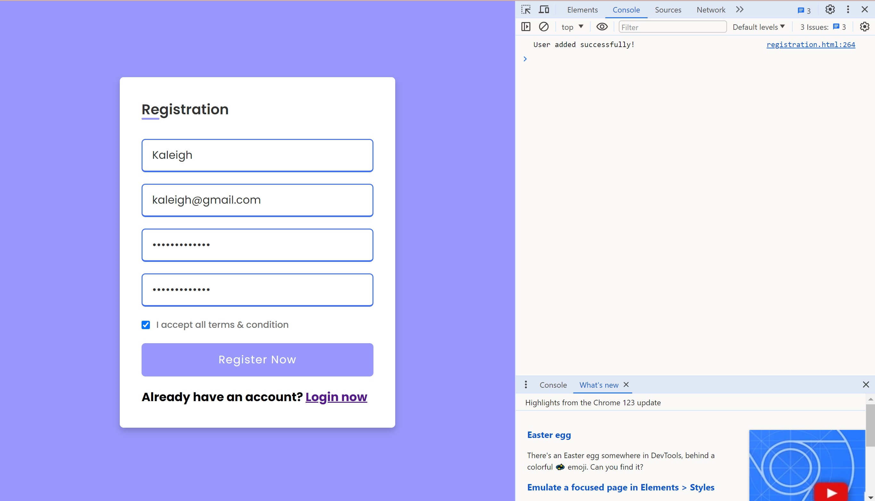 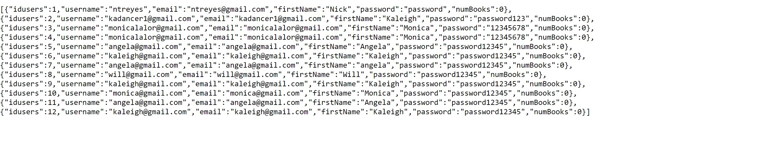

* + User must have an email address with an @ and a .host (not yet completed)
  + Password must be at least 8 characters/numbers long
    - If the user tries to register with a password less than 8 characters/numbers long, they will receive the following error:

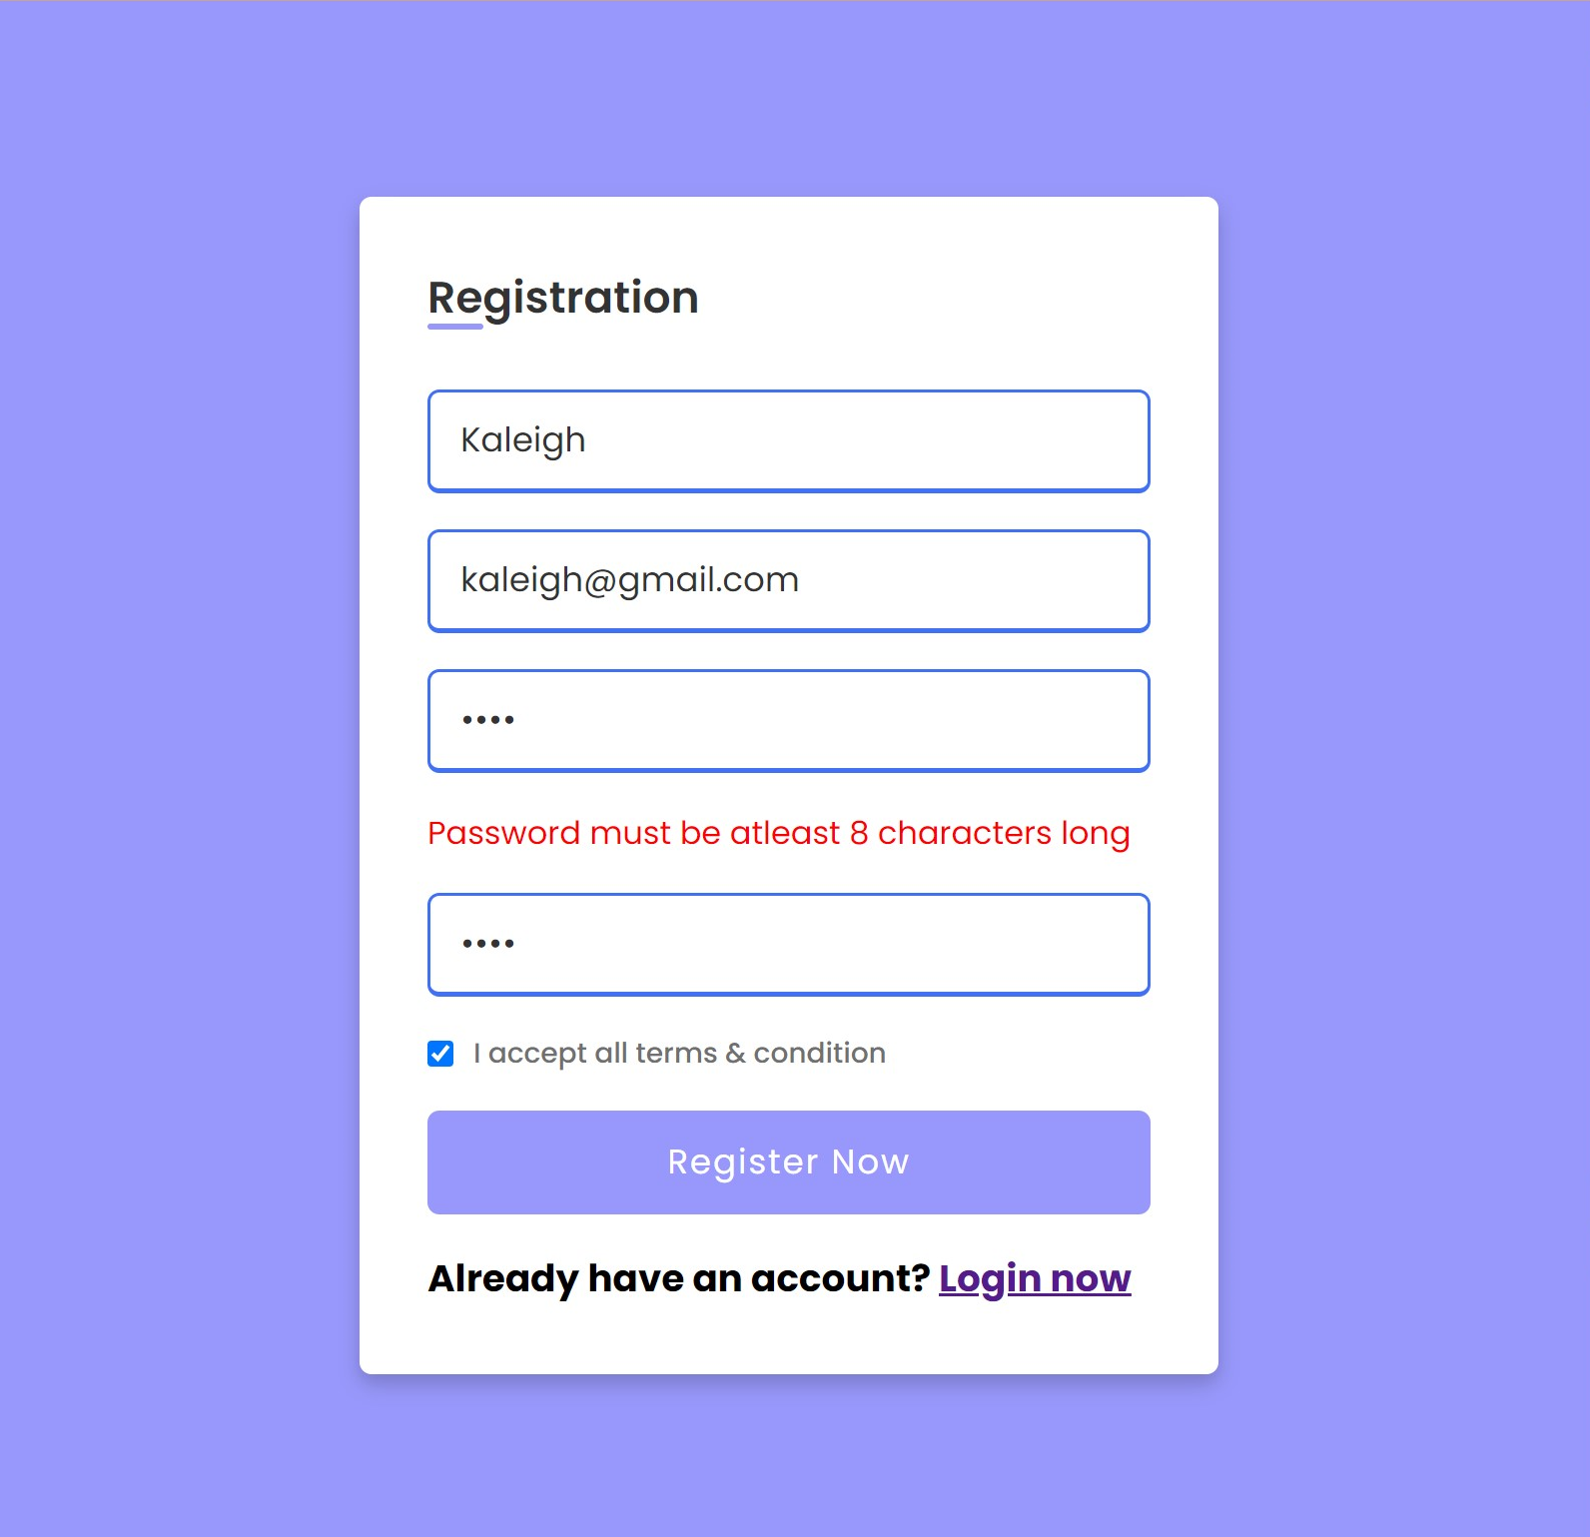

* + Password confirmation must match password
    - If the confirmation password is not the same as the password, the user will receive the following error:
  + All fields must be filled out
    - If a field is not filled out, the user will receive a popup error:

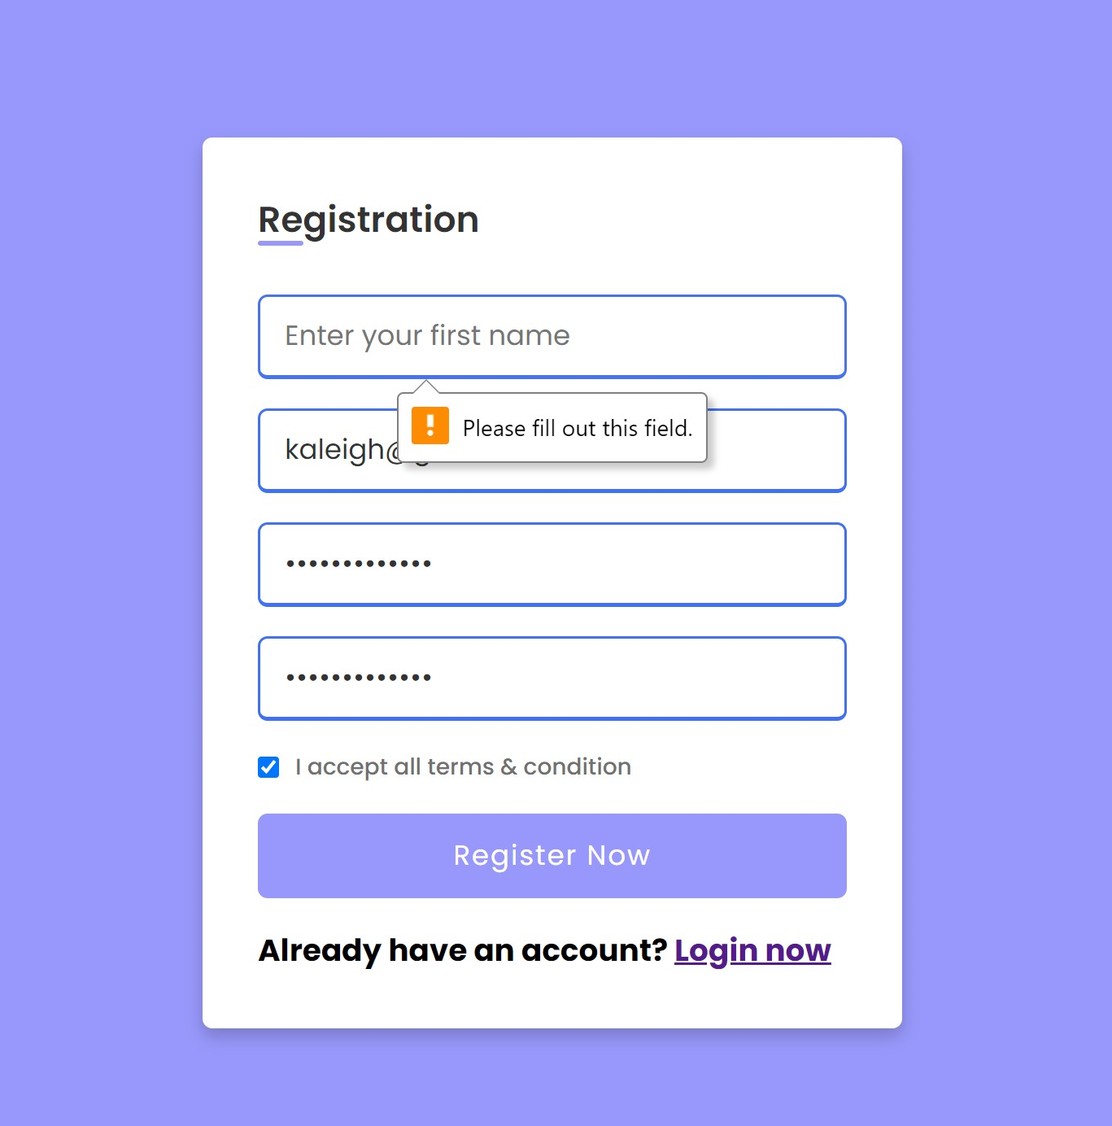 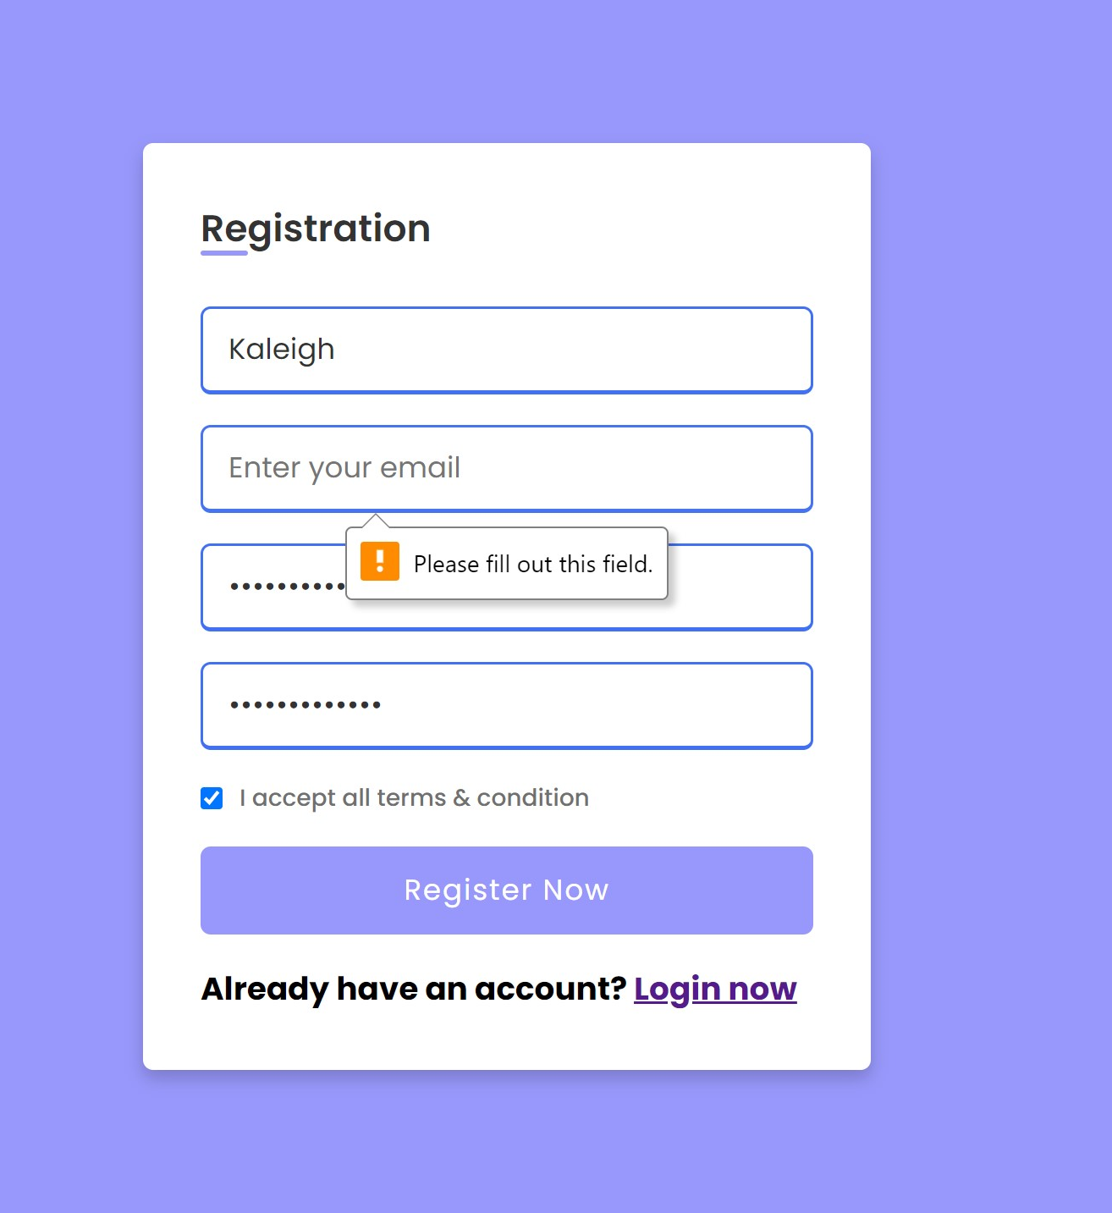

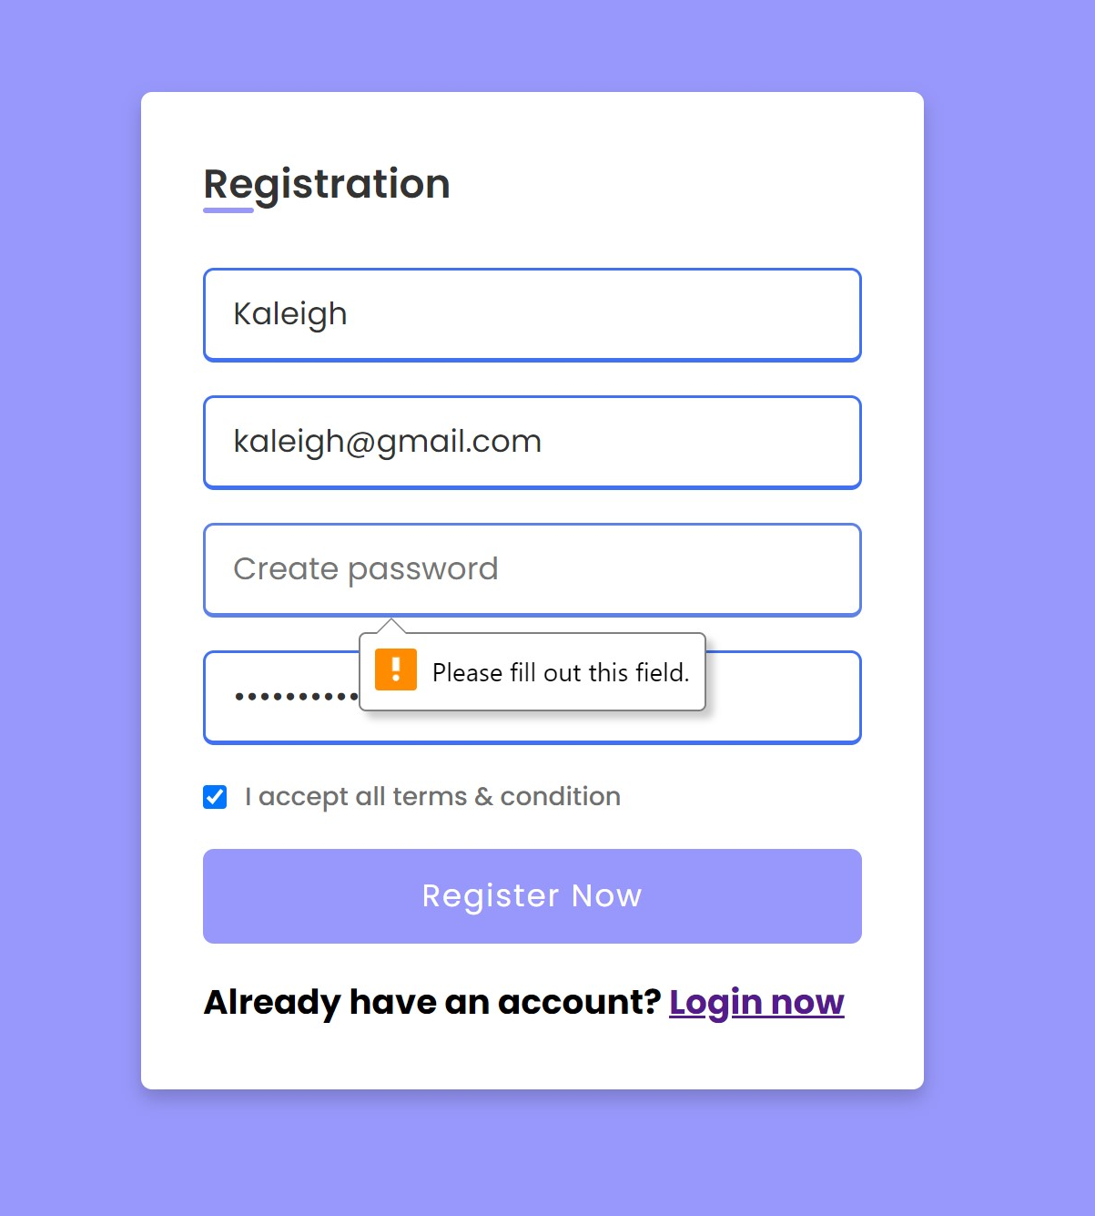 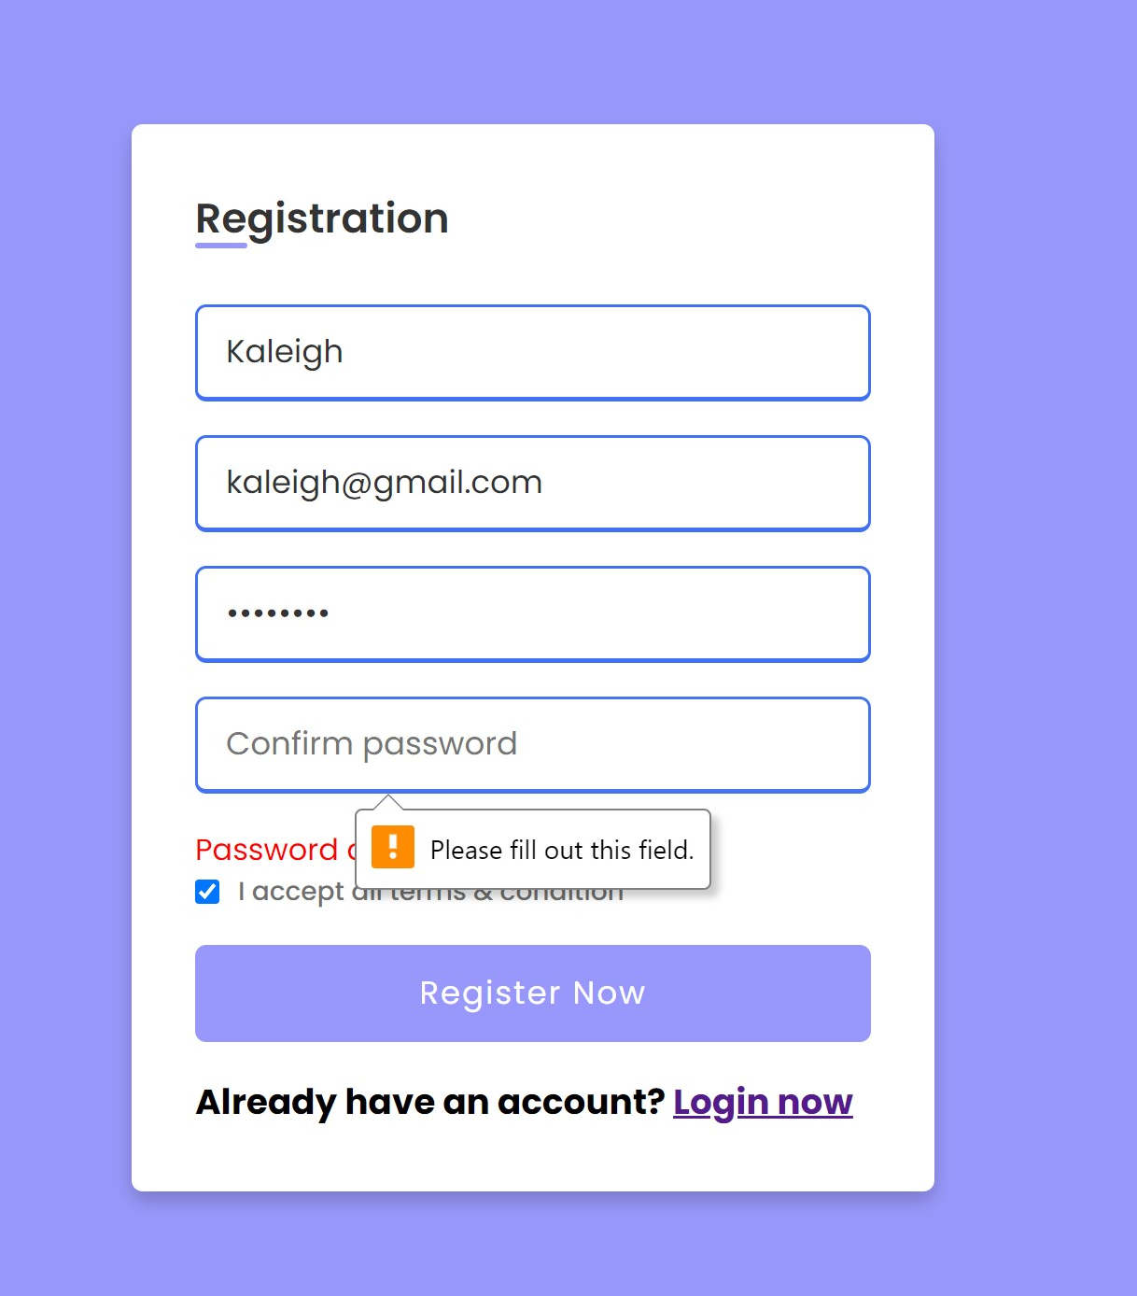

* Login testing:
  + Ensures user is in database
    - The user will enter their email address from signup and their password and click the Login Button, if it is correct they will be taken to the dashboard page.

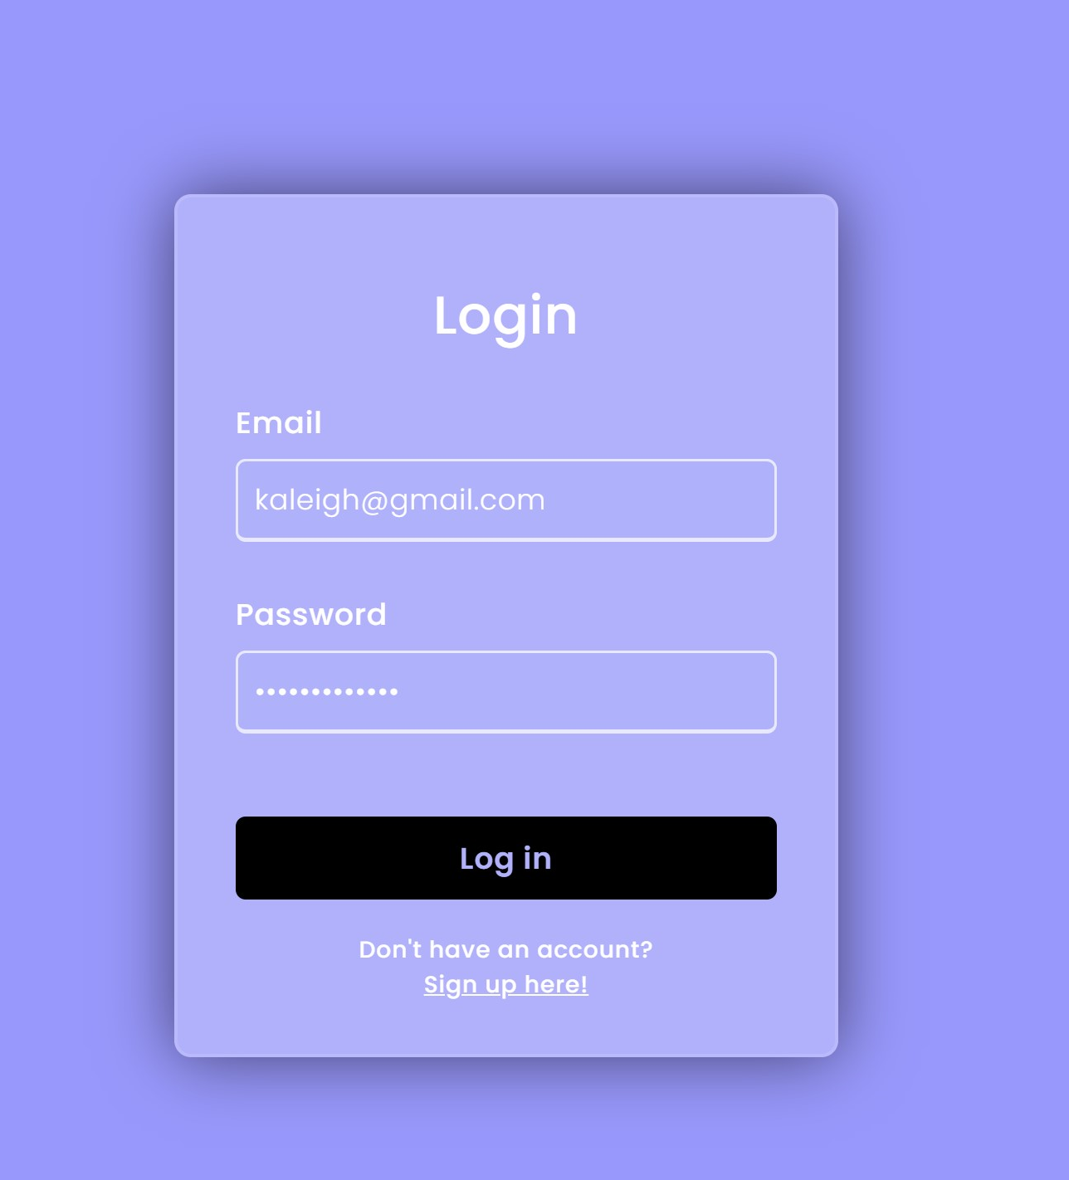

* + - If username or password is incorrect, the user will receive the following error:

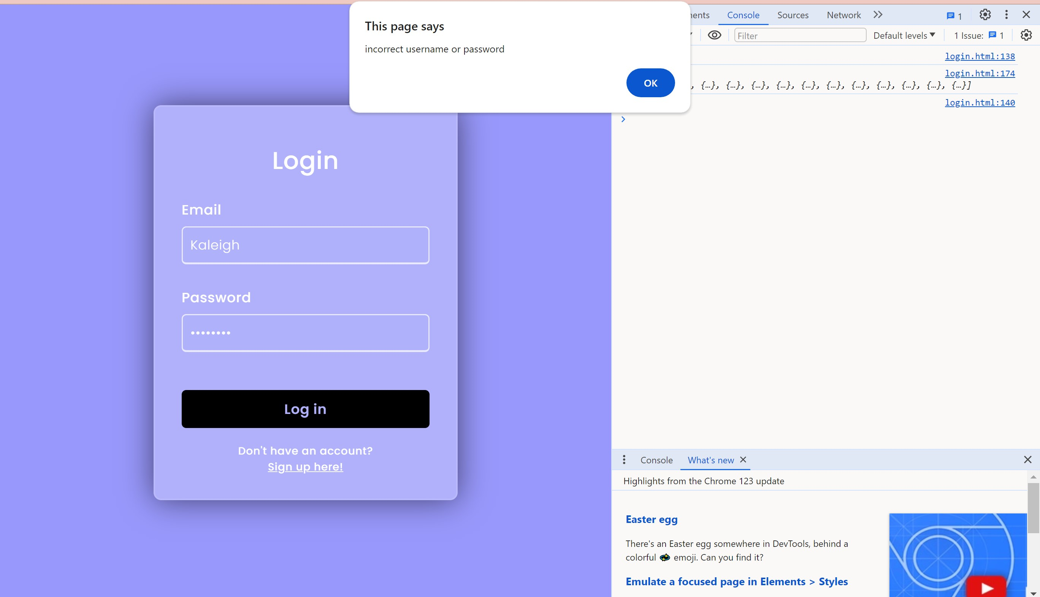

* + User cannot have two sessions open at once (not yet completed)
* Book testing:
  + Searching and adding books to personal library
    - The user can search a book to add, select “Get books” and the books will populate from the OpenLibrary database
    - Selecting “Add to Library!” adds the book to their personal library

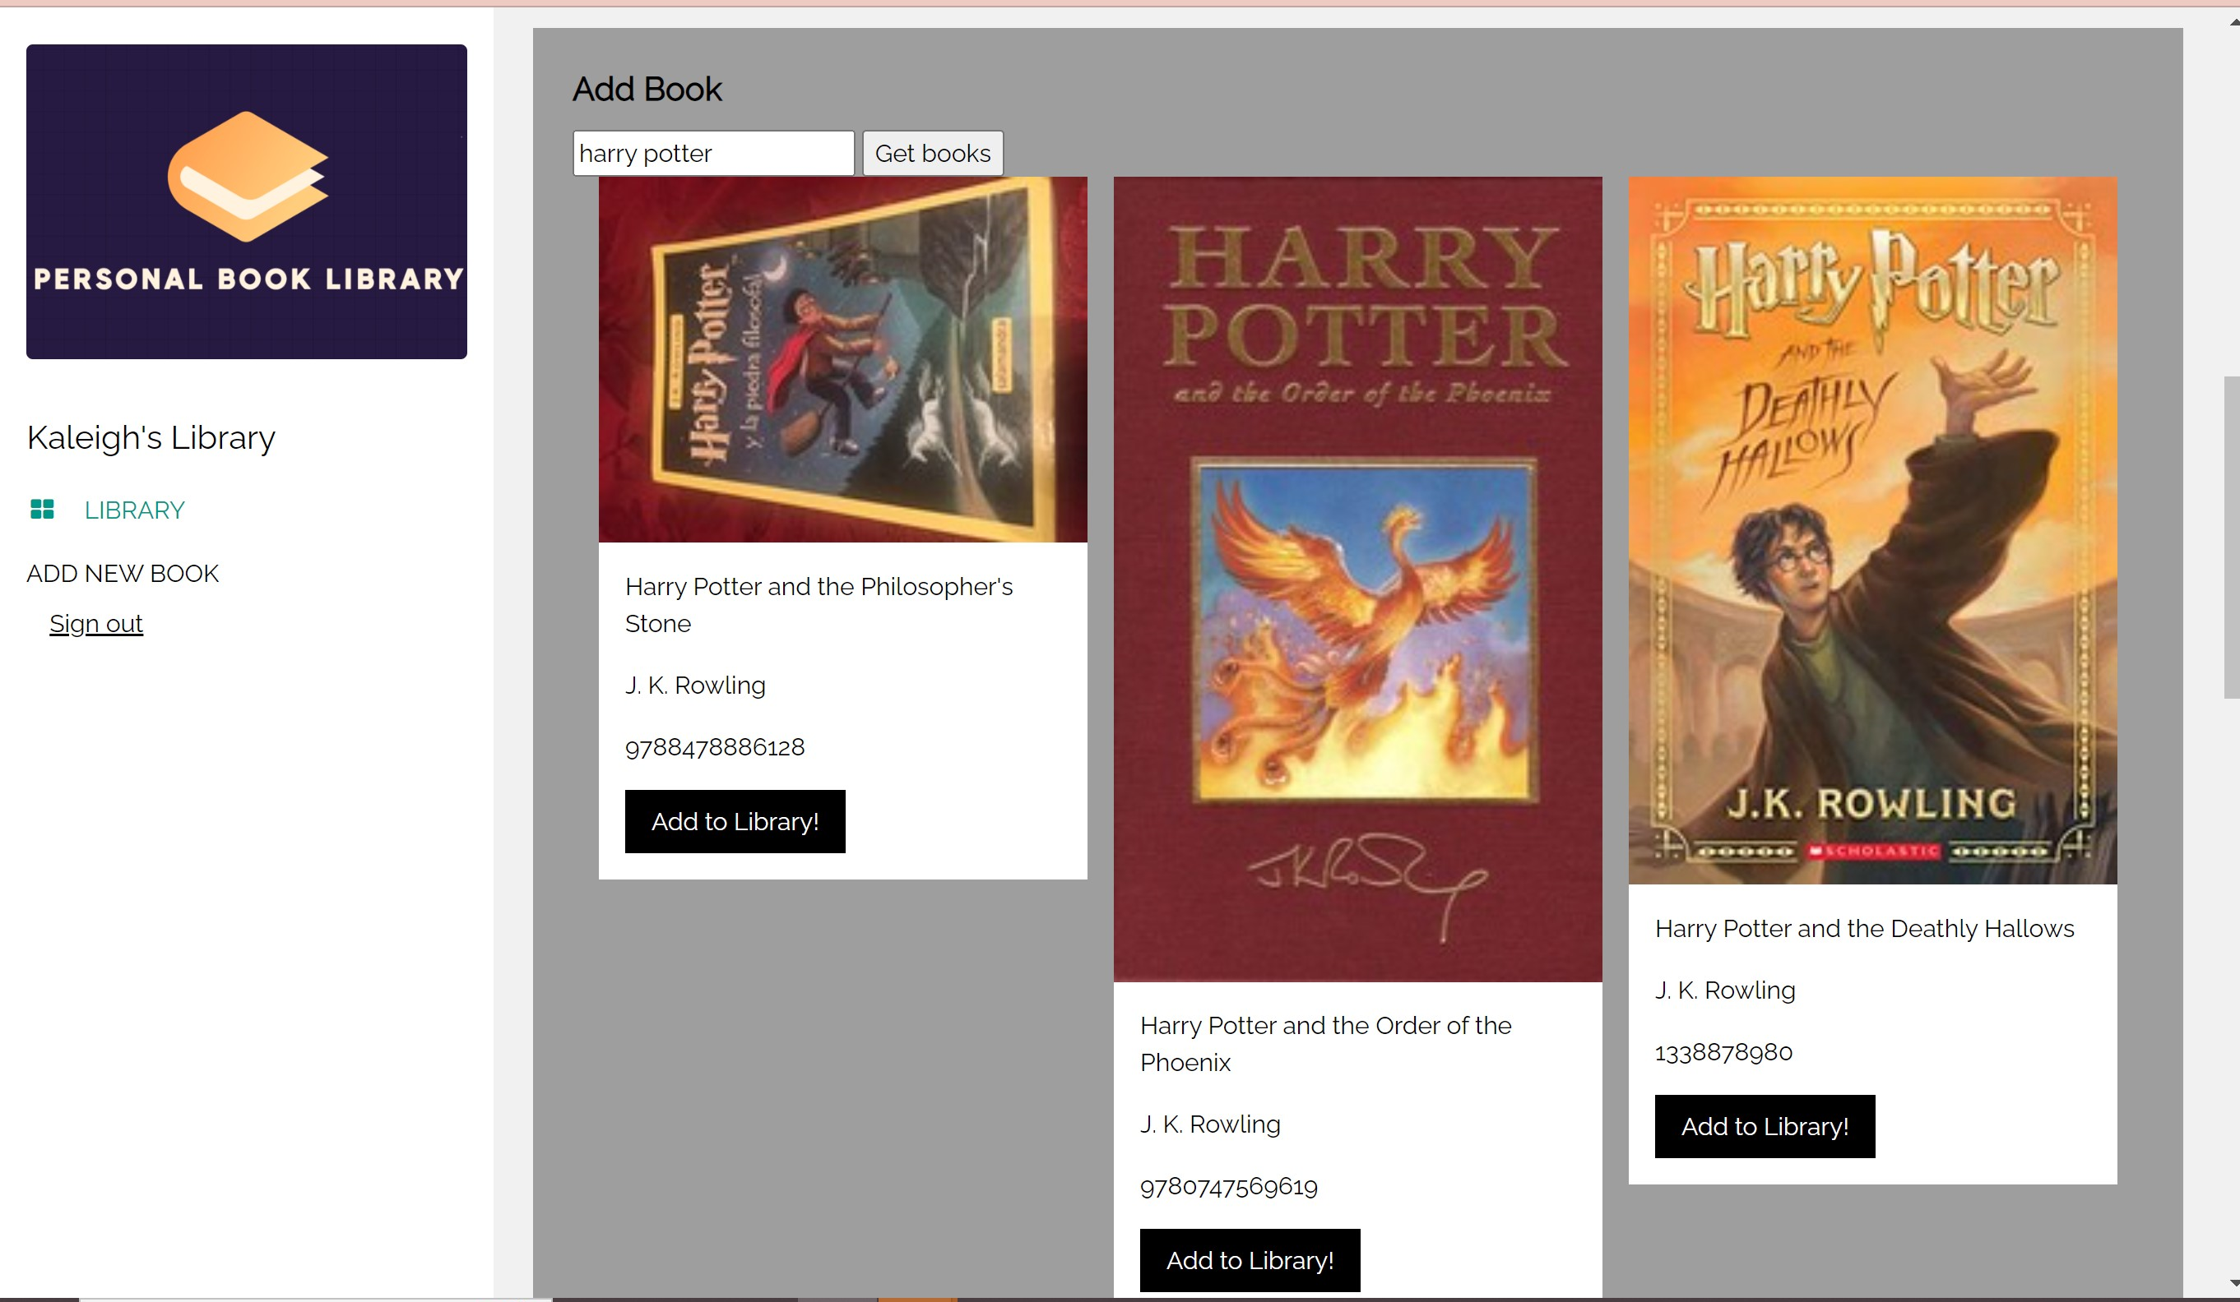

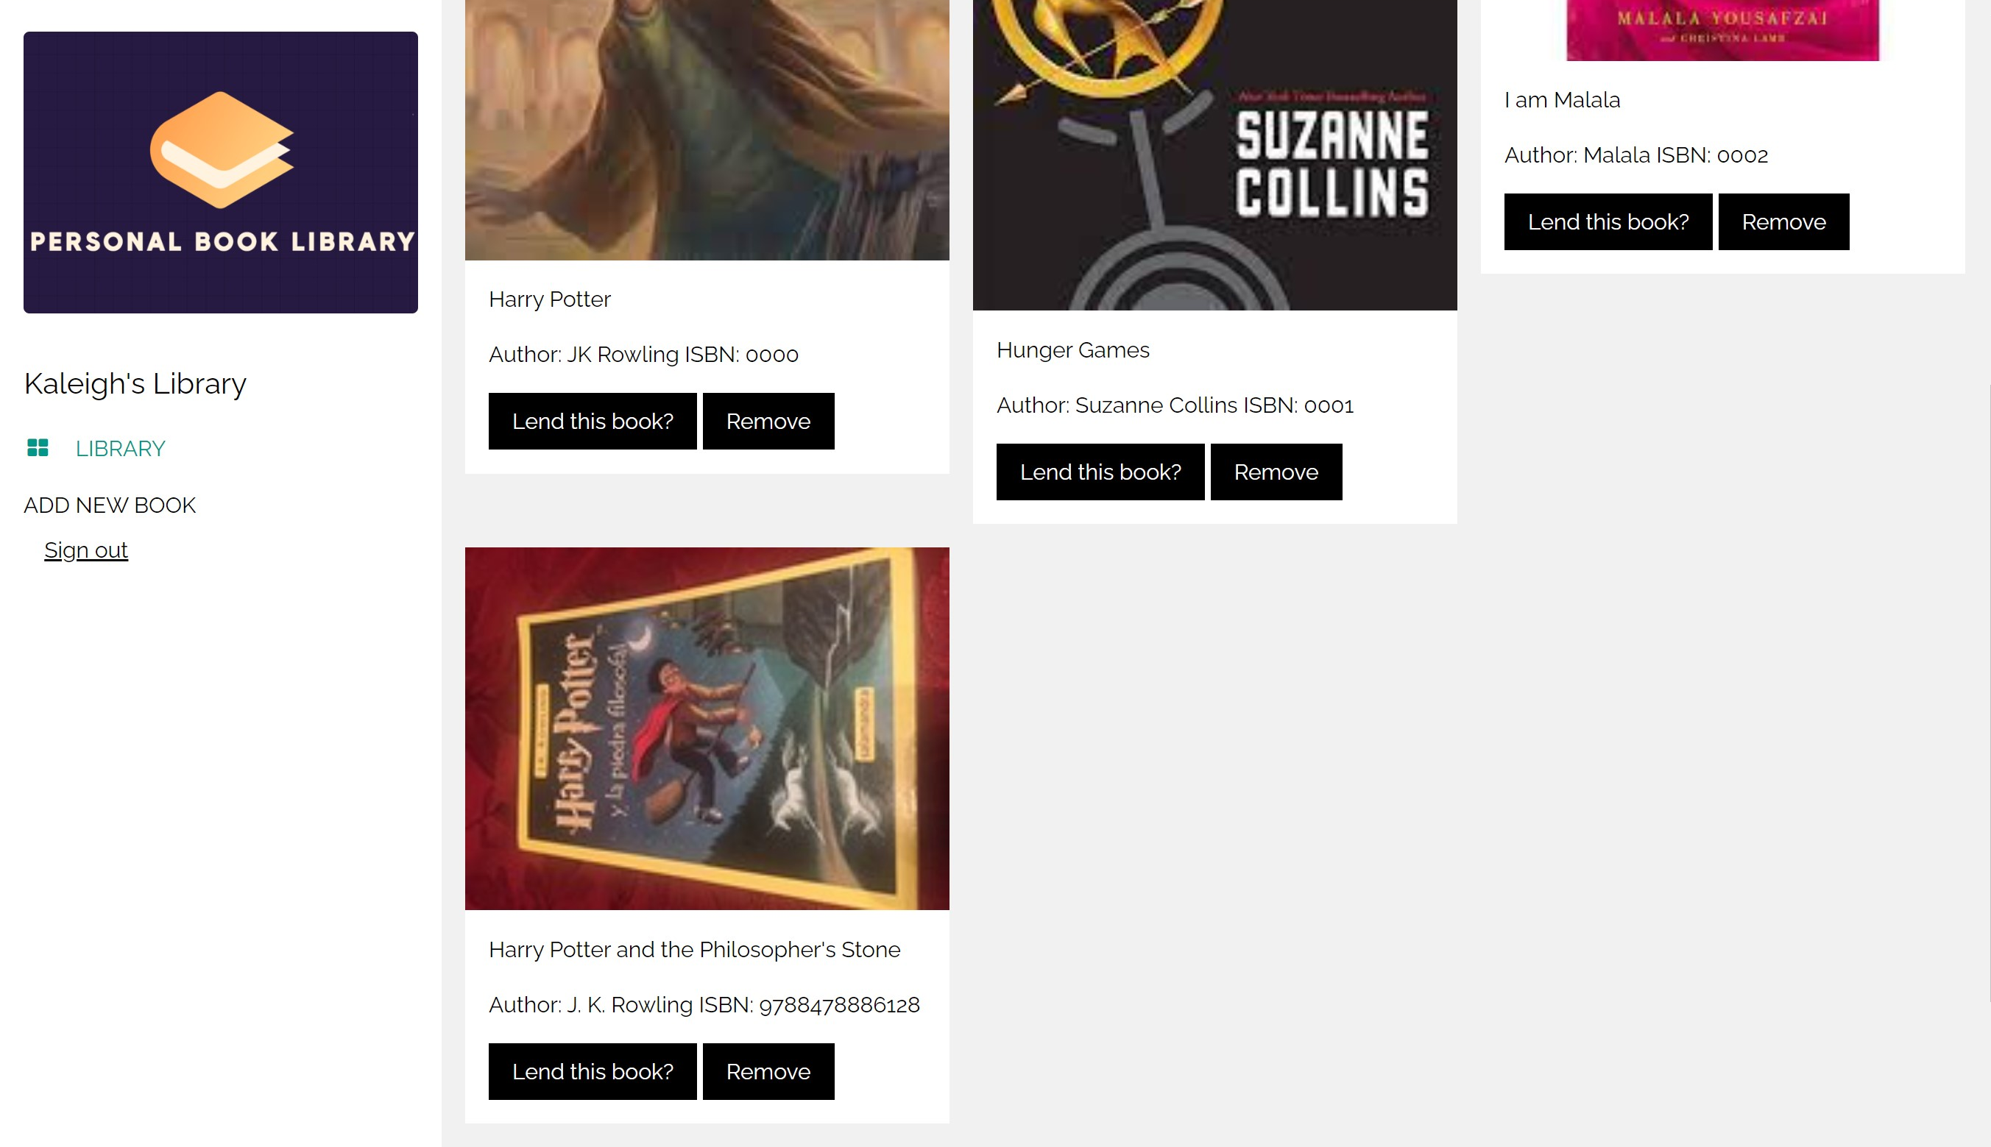

* + Removing books from library
    - Selecting “Remove” will remove the book from the library:

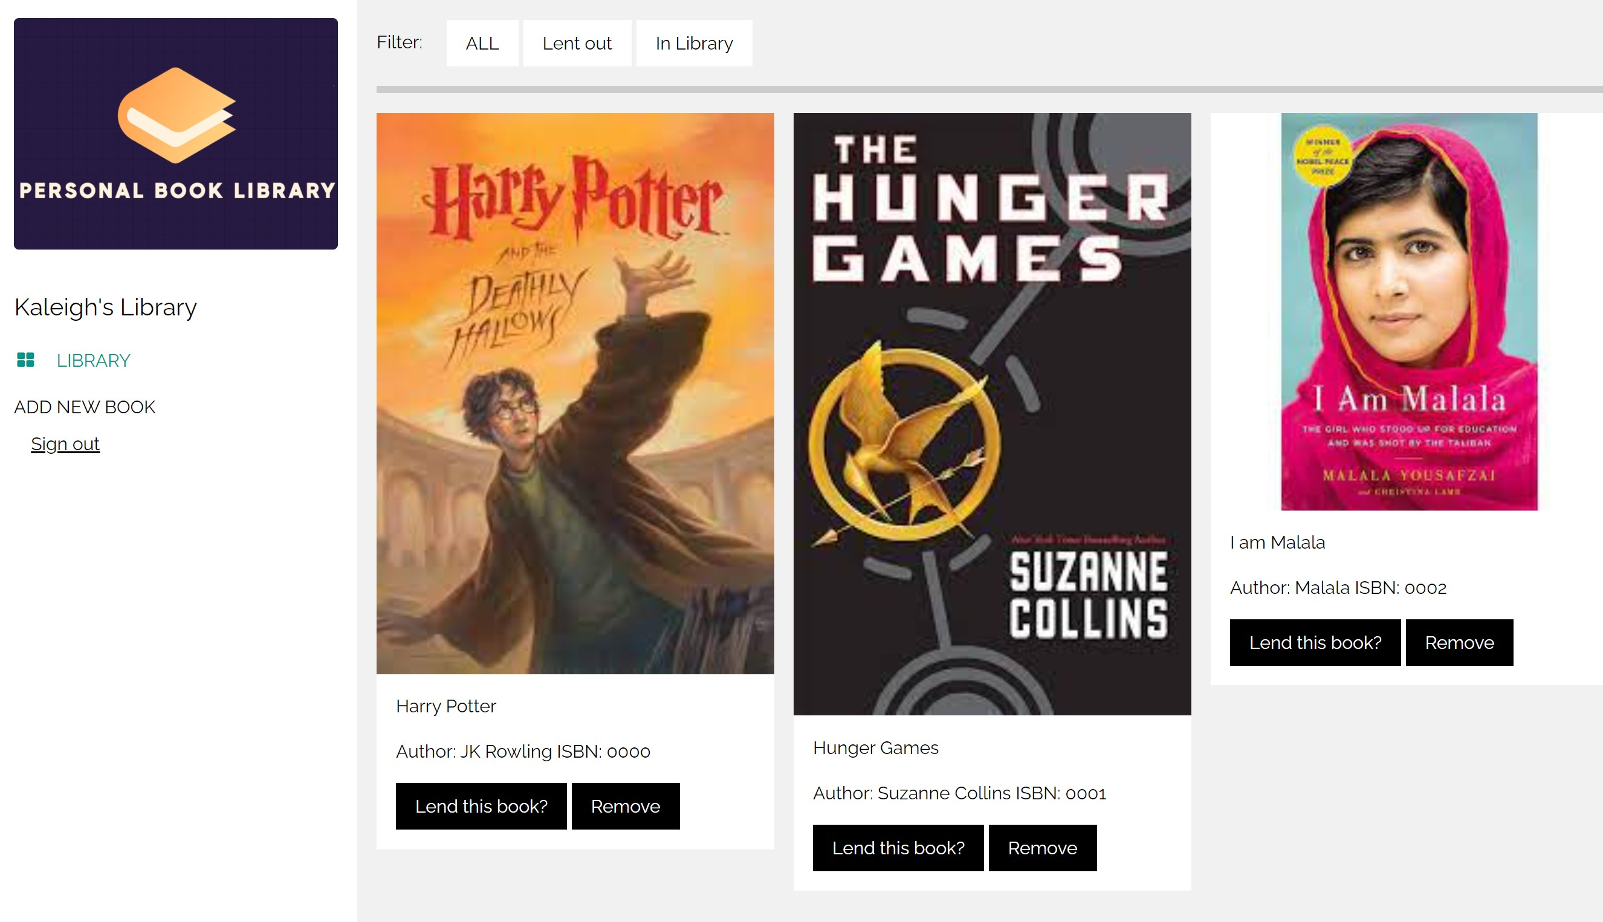

* + The following have not yet been completed:
  + Books are added to the database properly
  + Books can be removed from the database
  + Rent status can be changed
  + Reminder emails